CELL BALANCING CIRCUIT

8 Units (1 Unit = 3.2V, 6Ah) in series = 24V, 18A

TEMPERATURE SENSOR

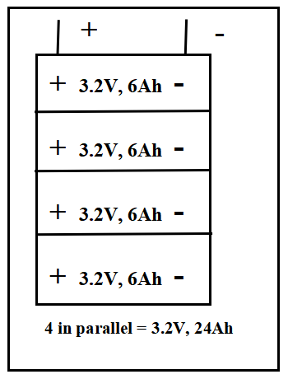
VOLTAGE SENSOR
VOLTAGE SENSOR
VOLTAGE SENSOR
VOLTAGE SENSOR
VOLTAGE SENSOR
VOLTAGE SENSOR
VOLTAGE SENSOR
VOLTAGE SENSOR
CURRENT SENSOR

Output of Microcontroller will be made avaialable to the android app via cloud

MICROCONTROLLER

MOBILE PHONE
CAN
H
L
CAN
To
USB
Computer
For
GUI Interface

